Sam Houston Association of Computing Scientists’

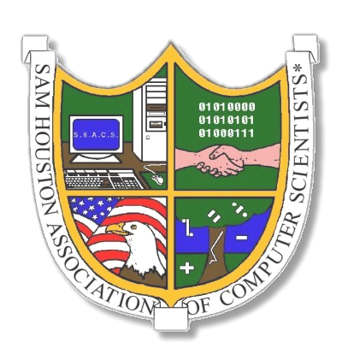

5th Annual Secondary Education Conference

An Association of Sam Houston State University

Sam Houston Association of Computing Scientists is hosting its Fifth Annual Secondary Education Conference at Sam Houston State University. The seminars are an opportunity for high school students and teachers to become better familiar with today’s leading technology as well as honing the presenter’s skills needed to be technology professionals.

The conference will be held in the Lee Drain Building on the main Sam Houston State University campus on Friday January 9, 2004. At-Door Registration will begin at 8:00 A.M. and will last until 9:00 A.M. Registration fee is $5.00 per person and pre-registration forms and fees can be (preferably) mailed to the Secondary Education Seminar Coordinator at the following address:

CS Department
Attn: SHACS
P.O. Box 2090
Huntsville, TX 77341-2090
Online Registration forms can be found at

http://www.shacs.org/SecEd.html

Seminars will start at 9:00 A.M. and will last until 2:30 P.M. There will be a 1-hour lunch break at 11:00 A.M. and drawings for door prizes will be held from 12:00 P.M. to 12:30 P.M.

Attached is a list of topics that we have offered in previous conferences. Please visit the Secondary Education homepage on the SHACS website for questions and updates by going to the previously mentioned URL.

Please see the attached schedule for descriptions and times of classes to be offered. Please visit the Secondary Education homepage on the SHACS website for questions and updates by going to the previously mentioned URL.

Attached to this invitation is a map to Sam Houston State University, a map of the Sam Houston State University campus, a list of motels and their phone numbers in the immediate area of the university, as well as a list of restaurants in the Huntsville area. Again all this information will be posted on the SHACS website (see above URL).

Hopefully this year will be as big a success as last year’s conference, as well as everyone learning something new while having fun in the process. Have a safe and happy Holidays, and we hope to see you on the 5th!

~SHACS

Schedule of Seminars
9:00 A.M. – 10:00 A.M.
To be announced

Network Gaming
An introduction into the various opportunities in the gaming industry. We will briefly discuss programming, design, artists, and play testing. We will then do a little play testing of our own.

10:00 A.M. – 11:00 A.M.
To be announced

Network Gaming
An introduction into the various opportunities in the gaming industry. We will briefly discuss programming, design, artists, and play testing. We will then do a little play testing of our own.

11:00 A.M. – 12:00 P.M.

Lunch

12:00 P.M. – 12:30 P.M.
Door Prizes

12:30 P.M. – 1:30 P.M.
To be announced

Network Gaming
An introduction into the various opportunities in the gaming industry. We will briefly discuss programming, design, artists, and play testing. We will then do a little play testing of our own.

1:30 P.M. – 2:30 P.M.
To be announced

Network Gaming
An introduction into the various opportunities in the gaming industry. We will briefly discuss programming, design, artists, and play testing. We will then do a little play testing of our own.

2:30 P.M. – 3:30 P.M.
Network Gaming
An introduction into the various opportunities in the gaming industry. We will briefly discuss programming, design, artists, and play testing. We will then do a little play testing of our own.

Maps

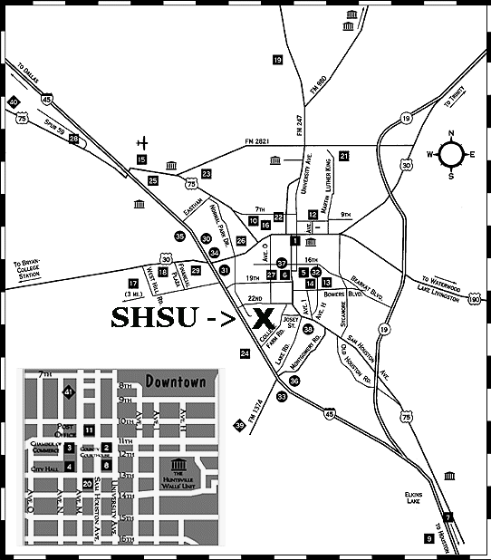

Huntsville, Texas

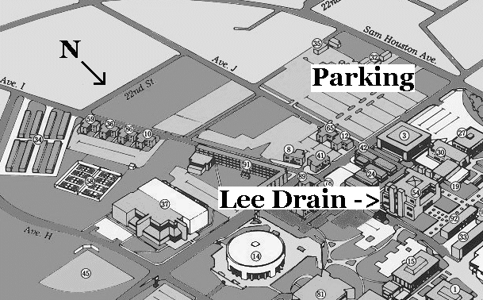

South end of Sam Houston State University

Hotels/Motels

La Quinta Inn

1407 I-45
- 800/531-5900 or 409/295-6454
- 122 Units, Pool, Continental Breakfast, Meeting & Banquet Rooms, Catering.
Motel 6

1607 I-45
- 800/4-MOTEL6 or 409/291-6927
- 122 Units, Pool.

University Hotel

Avenue H at 16th Street
- 409/291-2151
- Sam Houston State University, 98 Units, Meeting Rooms, Restaurant.
Sam Houston Inn

3296 I-45 S
- 800/395-9151 or 409/295-9151
- 76 Units, Pool, Meeting and Banquet Rooms, Continental Breakfast, Cocktails.
Econo Lodge

1501 I-45 N
- 800/55-ECONO or 409/295-6401
- 57 Units, Pool.
Rodeway Inn

3211 I-45
- 800/228-2000 or 409/295-7595
- 43 Units, Pool, Continental Breakfast, Jacuzzi.

Center Motel

1602 Sam Houston Avenue
- 409/295-5401
- 29 Units
Baker Motel

845 S. Sam Houston
- 409/295-3761

23 Units

